Pokhara University

Level: Bachelor | Semester – Fall | Year : 2008
Programme: BE |  | Full Marks: 100
Course: Digital Communication |  | Time : 3hrs.

Candidates are required to give their answers in their own words as far as practicable.
The figures in the margin indicate full marks.

Attempt all the questions.

 | - Compare digital communication with analog communication system and explain digital communication with the help of functional block diagram.  - Show that for each extra bit n used for representing each quantization level (coding) in uniform quantization the Signal to Quantization Noise Ratio increases by 6 dB. | 8  7
 | - Distinguish between differential PCM & Delta Modulation.  - What is slope overload distortion & granular noise in delta modulation & how it is removed in ADM.  - A signal g(t) band limited to 3KHz is sample at the rate 40% higher than the Nyquist sampling rate. The maximum acceptable signal to quantization error in sample is 0.6% of the peak amplitude g_{p}. The quantized samples are binary coded. Find the bandwidth of the channel required to transmit the encoded binary signal. If 24 such signals are time division multiplexed signal, determine the minimum transmission BW required to transmit the multiplexed signal. | 2  5  8
 | - State and explain Shannon’s channel capacity theorem. With necessary derivation show that the channel capacity does not tend to infinity as bandwidth is increased up to infinity.  - What is inter-symbol interference (ISI)? How Duo binary encoding helps to reduce the effect of ISI? Explain with the help of functional block diagram. | 7  8
 | - Explain QPSK with the help of block diagram of transmitter, receiver, and the signal constellation diagram.  - Derive the time domain expression for narrowband noise. | 8  7
 | - A rectangular pulse x (t) = rect (t) is passed through an ideal low-pass filter of bandwidth B. The amplitude response of filter is  H (f) = {1 -B ≤ f ≤B  0 otherwise  Find the power spectral density of the filter output y(t).  - Why is a matched filter called an optimum demodulator? Determine the maximum SNR for a matched filter demodulator for a signal pulse with energy E in presence AWGN with power spectral density N_{o}/2. | 8  7
 | - Define (i) Channel signal to noise ratio (SNR)_{C} , (ii) Output signal to noise ratio (SNR)_{o}, and figure of merit (FOM). Derive an expression for the figure of merit for an AM (DSB-AM) receiver using envelope detector.  - For the (7,4) Linear block code (Hamming code). Find the code word for message bit stream {0110}. If a code is transmitted and the error occurs at 6th bit position, find the corresponding syndrome value.  P I_{K}  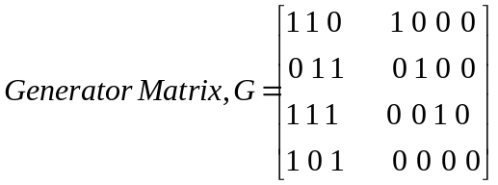  I_{n-k} P  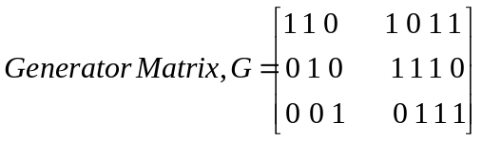 | 7  8
 | Write short notes on (Any Two)  - Probability error in QAM system  - Pre-emphasis and deemphasis networks in FM.  - The eye diagram | 2×5

